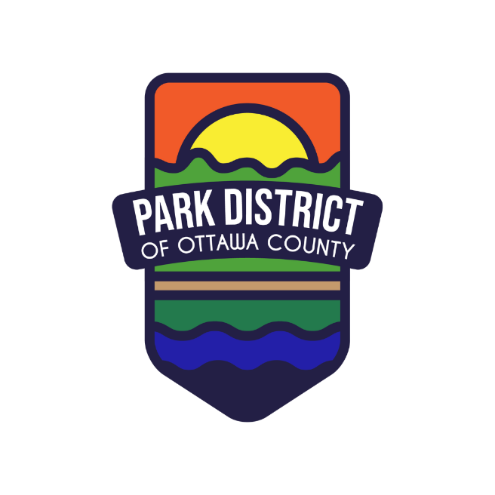
2026 Events and Programming
**Programs and Events subject to change

January | Nature Activity Kit: Winter Birds  January 5 from 4 to 6pm, Ottawa County History Mystery Trail Kickoff Event, Shores & Islands Ohio Port Clinton Welcome Center.  January 24 from 1 to 3pm, Hot Cocoa Walk, Elmore. Snowflake cutting craft, snowflake scavenger hunt, storytime in the log cabin “Snowflake Bentley” at 2pm, hot cocoa station

February | Nature Activity Kit: Snow Moon

March | Nature Activity Kit: Skunk Cabbage  Wednesday, March 11 from 6-7pm, Volunteer Orientation, Genoa Branch Library Meeting Room

April | Nature Activity Kit: Seeds/Planting  Wednesday, April 22 from 5-6:30pm, Earth Day Bike Ride on the North Coast Inland Trail  Friday, April 24 – Sunday, April 26, Catawba Island Boat Show, Catawba Island Club

May | Nature Activity Kit: Frog Calls  May 2 from 10am-2pm, Ottawa County Community Day,  Oak Harbor

June | Nature Activity Kit: America 250  June 24, from 10am-Noon, Bike Safety Camp, Genoa  June 28 from 11am-6pm, 46th Annual Portage River Festival, Elmore

July | Nature Activity Kit:  July 29, from 10am-Noon, Bike Safety Camp, Hopfinger Zimmerman Memorial Park

August | Nature Activity Kit:  Thursday, August 6 from 11am-3pm, Island Green Week on Put-in-Bay  TBD, Marblehead Lions Perch Festival, James Park
September | Nature Activity Kit:  September 1 – November 30, Outdoor Hiking Challenge, Countywide
October | Nature Activity Kit:  Saturday, October 10 – Sunday, October 11, 47th Annual Oak Harbor Apple Festival  October 22, Sunset Pumpkin Walk, Meadowbrook Marsh

November | Nature Activity Kit:

